Lymington and Milton Chronicle

SATURDAY, OCTOBER 21st, 1939
_______________________

SIX LOCAL RESIDENTS IN ROYAL OAK DISASTER
_______________________

Midshipman and Two Marines Among the Survivors,
But Three Ratings Lost
_______________________

TOTAL OF 424 SAVED OUT OF CREW OF 1,234
_______________________

Lymington and District had at least six officers or men serving in H.M.S. Royal Oak, the battleship which was torpedoed and sunk by a German submarine in harbour at Scapa Flow at 1.30 a.m. on Saturday last.
We regret to announce that three of them lost their lives, as did a member of a wellknown Brockenhurst family, but, happily, three others were saved, although no definite news is to hand as to whether any of the survivors is wounded.
Those who lost their lives in the disaster are:
Stoker G. Lilley, Marine A. Bartlett, Signalman R. G. Chalk,
of New Milton. Lymington Brockenhurst
The Borough heard with profound regret of the loss of these gallant men, all of whom were very well known and popular in the district, and the deepest sympathy will be felt with the bereaved families.
The names of the survivors are:
Marine D. O’Byrne Midshipman R. P. Pirie Marine A. Moppett,
New Milton Lymington Lymington
The Borough will join with the numerous friends of these families in the expressions of congratulations which they have received on the safety of Midshipman Pirie and Marines O’Byrne and Moppett.
The Royal Oak had a total complement of 1,234, consisting of 81 officers, and 1,153 ratings; survivors were 424 – 57 officers, 367 ratings; lost 810 – 24 officers, 788 ratings.

On the Borough’s Roll of Honour

STOKER LILLEY
_______
One of the victims of the “Royal Oak” tragedy was Second-class Stoker Harold George Lilley, aged 19 years, of The Hope, Peckham Avenue, New Milton, whose father was drowned at sea 13 years ago.
George lived with his step-father and step-mother, Mr. and Mrs. W. H. Hill, and the deepest sympathy is felt with the family in their bereavement.
Deceased and his twin brother Bob were the sons of the late Mr. G. H. Lilley, Mrs. Hill’s second husband, and Mrs. Hill has brought them up since boyhood.
George, who would have been 20 next February, joined the Navy ten months ago, and when the Royal Oak was commissioned last June, he was appointed a member of the crew, and she was his first ship. Prior to joining up George was employed as a gardener by Mr. Cecil Dudfield, of Thornilee, Ashley Road.
He was very popular in the district and a more good-natured boy it would have been difficult to meet. Always very keen on sport, he had won a number of medals and cups for his prowess in this direction. Since leaving school his name was well known in local football circles as a regular scorer of goals, first for New Milton and then the Hordle Spurs Football Club.
When at New Milton Council School George played football for the New Forest and Hampshire, and also ran in the 100 yards in the National Schools’ Sports at Blackpool in 1933.
George’s twin brother, Bob, who was employed at the New Milton Railway Station, joined the Army in October, 1938, and is now serving “somewhere in France.” One of George’s best friends was Desmond O’Byrne, who was serving in the same ship, and who was amongst the survivors. They generally travelled to and from Portsmouth together on their leaves, and had been pals for a number of years.
The month of October has been a tragic one indeed for the family, for Mrs. Hill’s first husband, Mr. George Webb, who was in the Tank Corps, was killed in France in October, 1918. Her second husband, Mr. George Harold Lilley, was a leading stoker in the Royal Navy and had only 18 months of his 22 years left to serve when he met his death in a similar way to that of his son, 13 years later.
Mr. Lilley was serving in the sloop H.M.S. Valerian, which was on its way back to England when, on October 22nd, 1926, it was struck by a hurricane off Bermuda and sank with the loss of 89 lives.

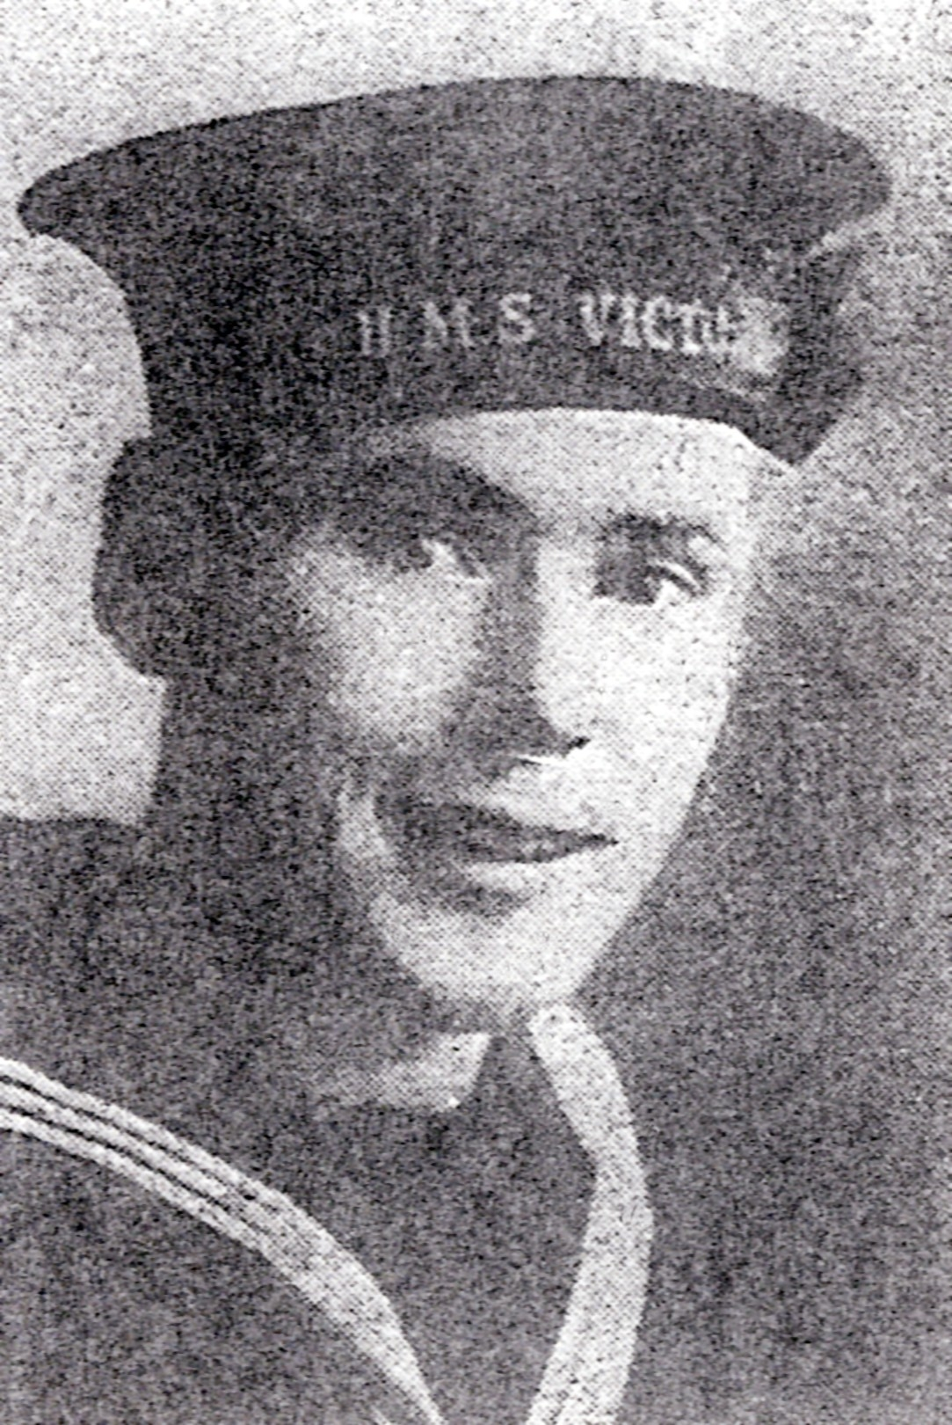

Stoker George LILLEY, New Milton

